MAKING BETTER VARIETY DECISIONS

COFT 1997
Collaborative On-Farm Tests of Winter Wheat Varieties

Objective
Compare on-farm performance of
RWA-resistant “Halt” to RWA-susceptible “TAM 107”

Trial Conditions
..- Grower plants and harvests with own equipment
..- Long (1/4 mile), narrow (wider than header) strips
..- Varieties planted side-by-side
..- Grower receives 100# seed each variety
..- 18 tests in 9 counties (below) where RWA is common

Cooperative Extension Agents Make It
Work
..- Recruit volunteer cooperators.
..-Distribute seed and guidelines.
..- Visit tests fall, spring, summer.
..- Responsible for harvest.
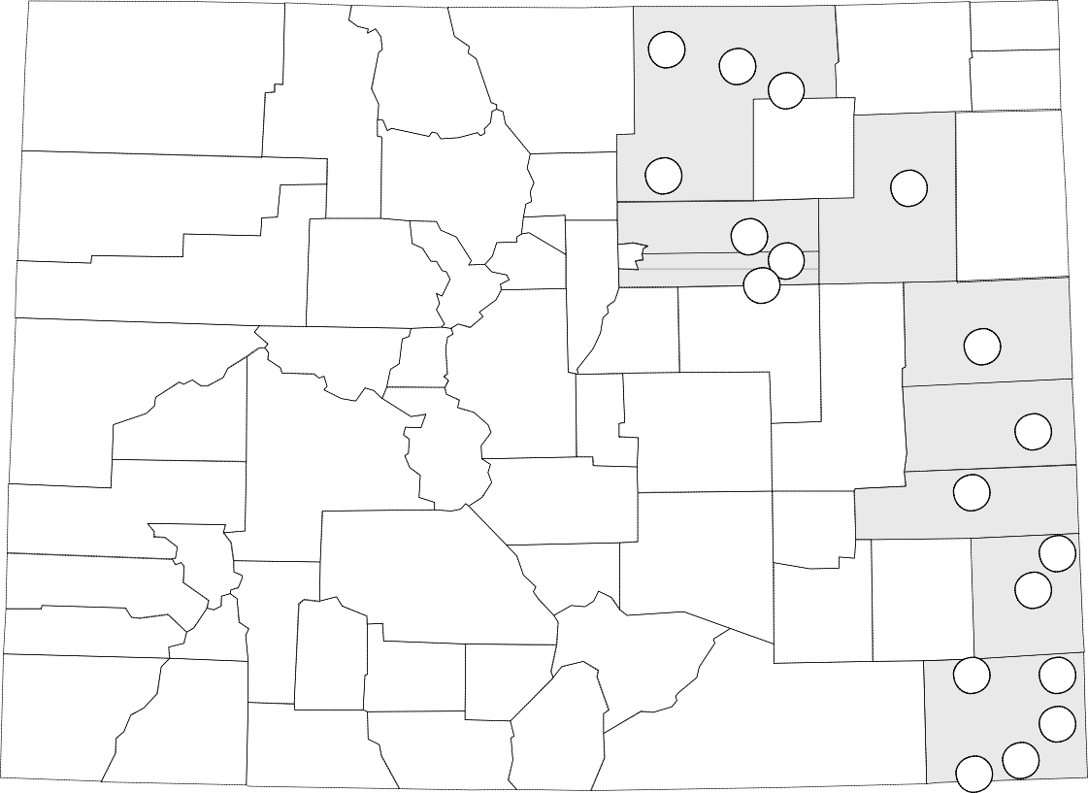..- See list of agents on next page.

1996-97 Production Constraints
..- Fall and spring drought
..- Widespread wheat mites
..-Wheat Streak Mosaic Virus
..-Russian wheat aphid

Results
..- Halt = TAM 107 when no RWA
..- Halt > TAM 107 with RWA present

Results of Collaborative On-Farm Testing of
Winter Wheat Varieties
Yield
#map County Halt TAM 107 bu/ac
1 SE Baca 24.4 25.8
2 NW Baca 22.1 23.0
3 SW Baca 14.5 12.2
4 SW Baca 24.2 17.7
5 NE Baca 62.2 56.3
6 NE Prowers 33.9 32.1
7 NC Prowers 50.9 39.2
15
16
17
Weld

14

Adams
12
Arapahoe 11
10

13

Washington

Kit Carson

18

Cheyenne

8 NE Kiowa 25.1 27.0
9 NE Cheyenne 33.9 34.4
10 NE Arapahoe I 27.4 24.3
11 NE Arapahoe II 22.6 21.6
12 SE Adams 15.3 15.8
13 NC Washington NE 38.5 39.3
14 SW Weld 40.1 28.6
15 NW Weld 34.3 38.4
16 NC Weld 24.5 21.1
17 NE Weld 27.1 29.6
18 C Kit Carson 52.1 54.8
Average Yields (bu/ac) | 31.8 | 30.1
Average Test Wt (lb/bu) | 59.3 | 58.3

9

8
Kiowa

6

7
Prowers

2 5

Baca 1

4
3

1997-1998 Collaborative On-Farm Tests

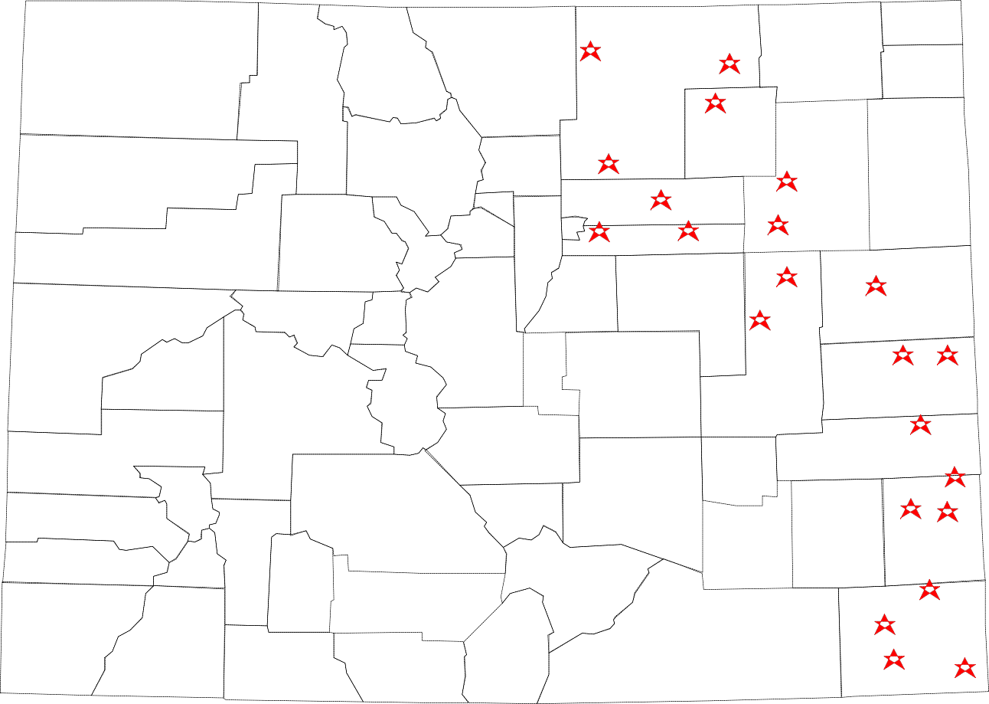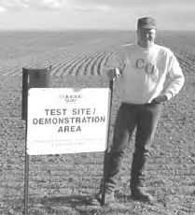The Colorado Wheat Producers who, for the good of the whole wheat community, donate the use of their land, labor, and machinery to make on-farm testing possible.

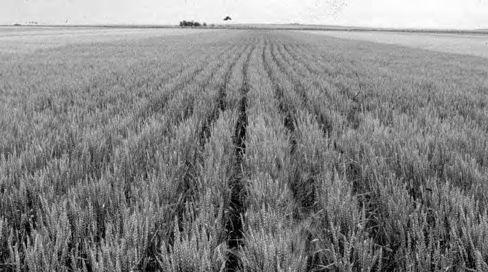The Cooperative Extension Agents MAKING ON-FARM TESTING WORK Tim Macklin - Baca County
Dick Scott - Prowers County

Ed Enderson

Mertens

George Ellicott - Kiowa County Ron Meyer - Kit Carson County Kurt Jones - Lincoln County

Bill Warren
Ed Richardson

Bruce Bosley - Morgan County
Joe Westoff Ken Remington

Ron Jepson - Adams County
Jerry Alldredge - Weld County
Bruce Converse
Joe Kalcevic

Kenny Pottorff

Ross Hansen
Don LeValley

Scott Smith

Rex Waugh

Kurt Jones
1998
Four Varieties
Halt
TAM 107
Prowers (Lamar R32)
Yumar (Yuma R21)
Burl Scherler

Fred Williams

John Stulp
David Heck
Randy Shaw

Bob Wood
Mike Whittler
Tim Hume

