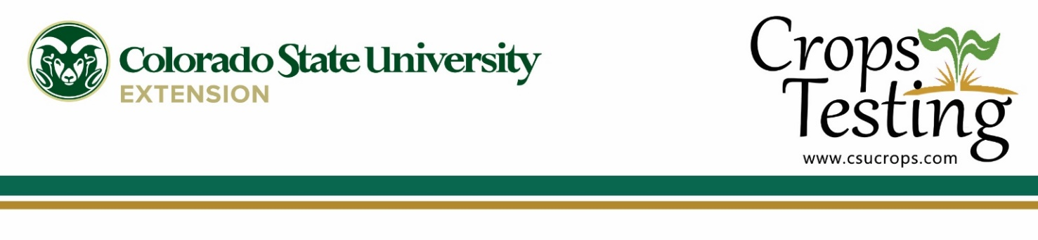
For Immediate Release

Crops Testing Program
Department of Soil and Crop Sciences
Office (970) 491-1454
Cellular (970) 690- 9259
jerry.johnson@colostate.edu

By Wilma Trujillo Sally Jones-Diamond
Area Agronomist Research Agronomist
Ph: (719) 522-3200 Ph: 970-214-4611
wilma.trujillo@colostate.edu sally.jones@colostate.edu

CSU Wheat Planting Decisions Webinar

Colorado State University (CSU), the Crop Testing Program, and CSU Extension are inviting wheat growers to the Annual Wheat Planting Decision Webinar. This year, the meeting will be online on August 18th at 8:30 am via Zoom. This online live-meeting will offer growers insights into the highest yielding varieties in the 2021 CSU Uniform Variety Performance Trials and Collaborative On-Farm Tests (COFT).

Growers looking to increase yield and decrease risk will want to plant the best possible wheat variety this fall for top yields next summer. CSU Extension Specialist Dr. Jerry Johnson and Research Agronomist Sally Jones-Diamond will present the CSU Uniform Wheat Variety and COFT results for 2021 and variety recommendation. Dr. Esten Mason, CSU Wheat Breeder, will talk about new varieties and releases, important traits, and new developments in the wheat breeding program at CSU. The Colorado Seed Growers Association Director, Laura Pottorff, will present on the availability and values of certified wheat seed and the Plant Variety Protection Act (PVPA).

Wheat growers will have first-hand information on current and new varieties, their resistant to drought and tolerance to diseases. This meeting is a great opportunity to ask the experts any questions on the CoAXium System, solid and semi-solid stem wheat varieties or other issues affecting wheat production in Colorado.

For more information on the meeting and to register (free to attend), please visit www.csucrops.com.

*****

